**IDEATION PHASE**

**BRAINSTROM AND IDEA PRIORITIZATION TEMPLATE**

|  |  |
| --- | --- |
| **Date** | 17 September 2022 |
| **Project Name** | Global Sales Data Analytics |
| **Maximum Marks** | 4 marks |

**Brainstorming and Prioritization Template:**

Brainstorming provides a free and open environment that encourages everyone within a team to participate in the creative thinking process that

leads to problem solving. Prioritizing volume over value, out-of-the-box ideas are welcome and built upon, and all participants are encouraged to collaborate, helping each other develop a rich number of creative solutions. Use this template in your own brainstorming sessions so your team can unleash their imagination and start shaping concepts even if you're not

sitting in the same room.

Reference: <https://www.mural.co/templates/empathy-map-canvas>

Step-1: Team Gathering, Collaboration and Select the Problem Statement

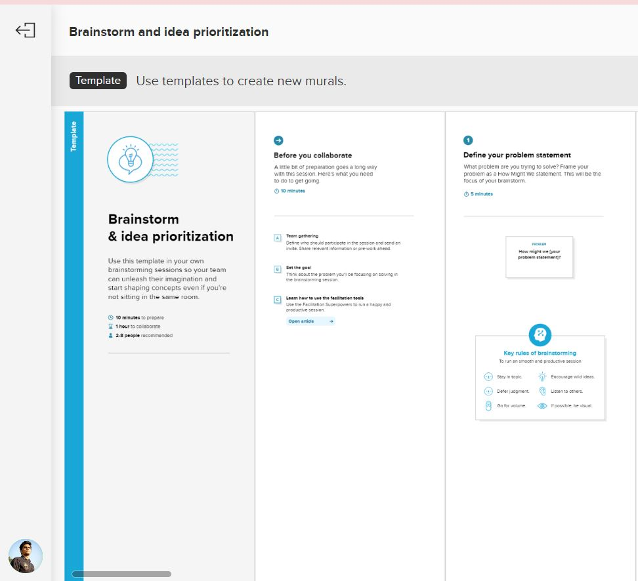

Step-2: Brainstorm, Idea Listing

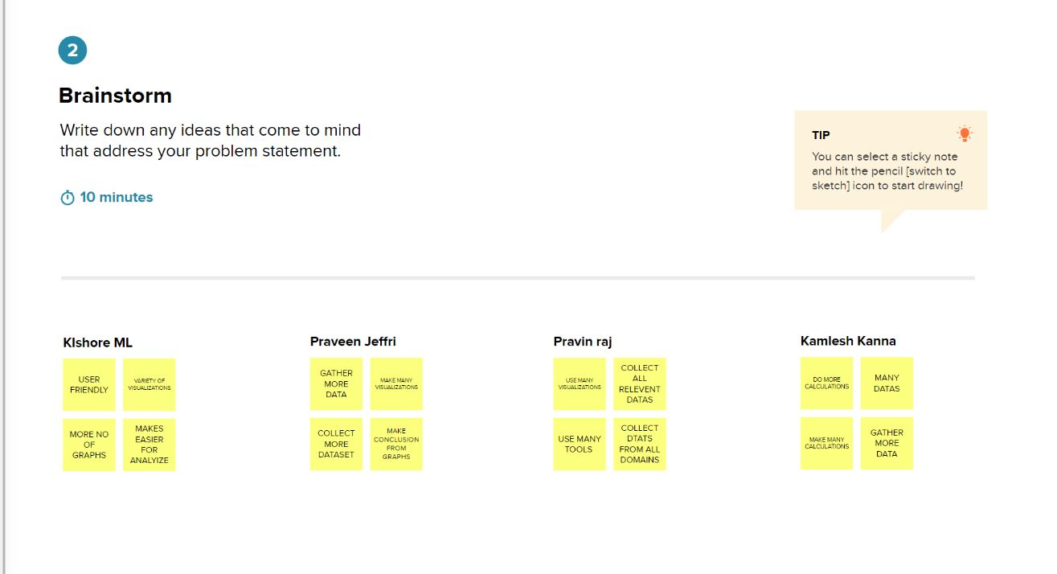

Step-3: Grouping

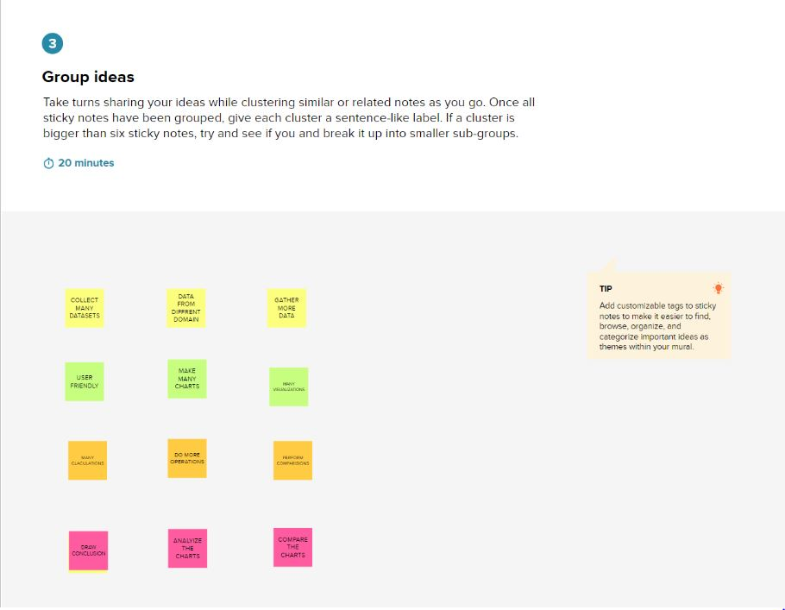

Step-4: Idea Prioritization

